Solution Architecture

Date | 06 July 2026
Team ID | SWTID-2026-1392
Project Name | Credit Card Approval Prediction
Maximum Marks | 5 Marks

Solution Architecture Diagram:
Provide a high-level visual representation of your solution's architecture. Use the structural layout below as a template to map out your Presentation Layer, Application Layer, and Data Layer. Fill in the specific technologies and components for your project directly into the boxes to create your architectural diagram.

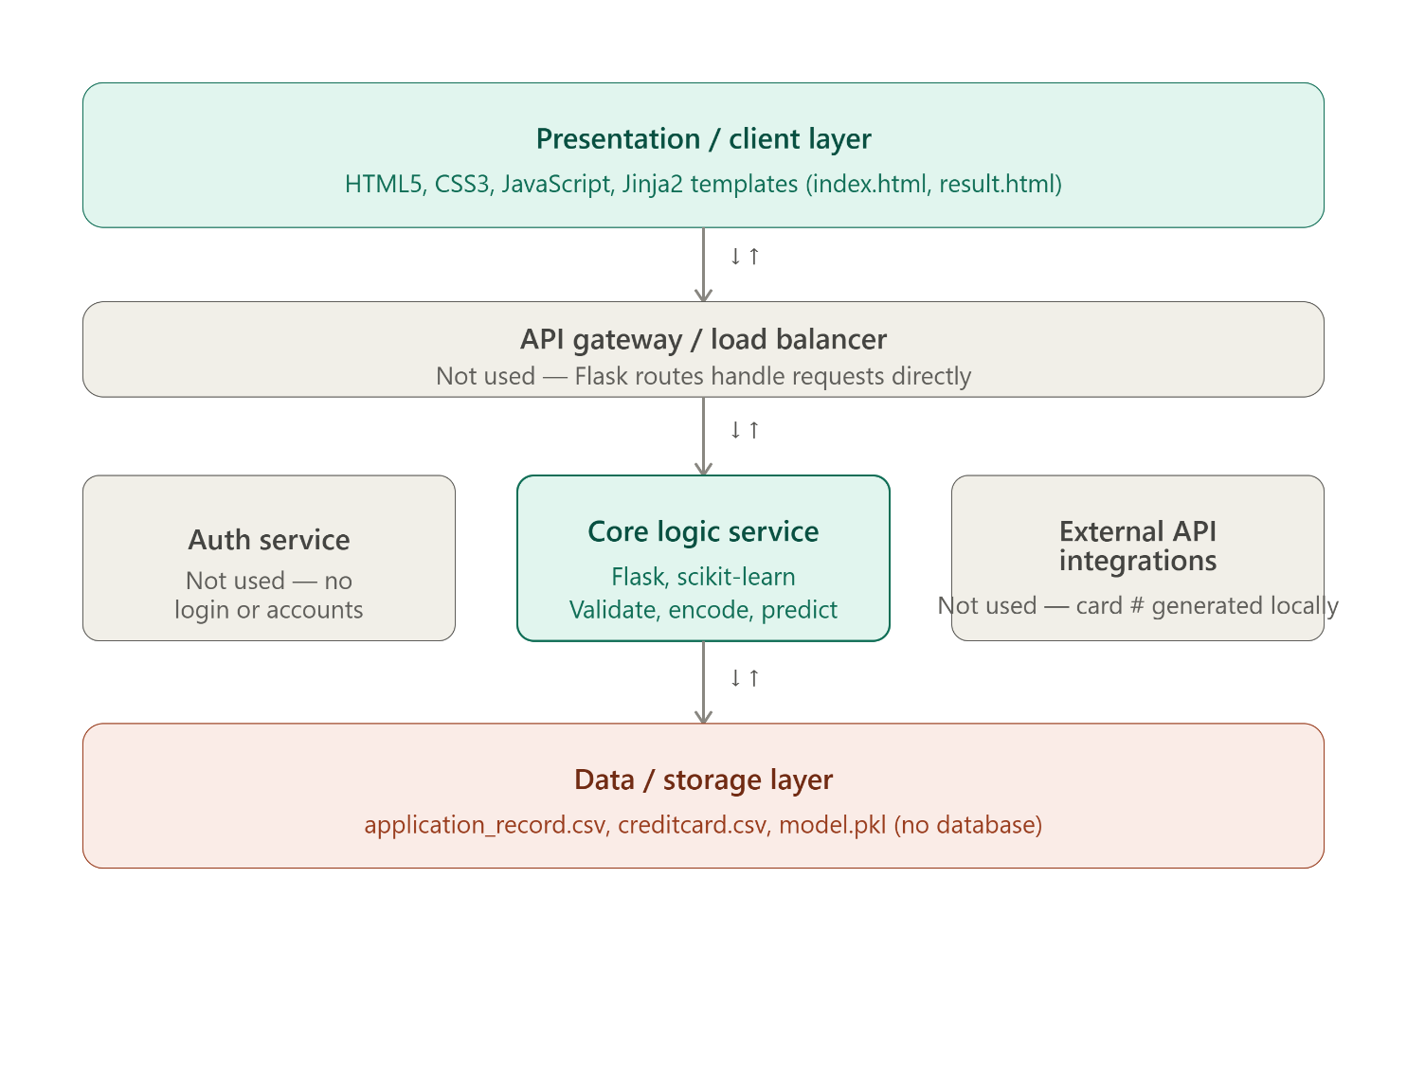

Component Description Table

Component Name | Description / Role in Architecture | Technologies Used
Presentation Layer | Renders the application form with a live credit-card preview and displays the stamped approval/decline result page | HTML5, CSS3, JavaScript, Jinja2 (Flask templates)
API Gateway | Not applicable — Flask's built-in routing handles the two endpoints directly, no separate gateway | Flask routing only
Microservices (Core Logic Service) | Single service that validates form input, encodes categorical fields, and runs the trained ML model to produce a prediction | Flask, Python, scikit-learn, pickle
Database | No database — training data comes from flat CSV files, and the trained model/encoders are stored in one pickled file loaded at startup | CSV files (application_record.csv, creditcard.csv), model.pkl

